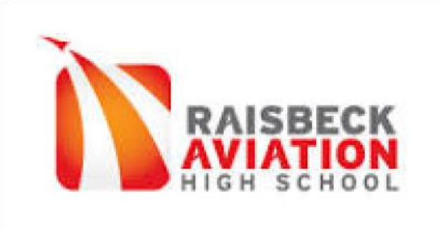
24 April 2022

Sue Murphy, State Director
Washington Science Olympiad

Dear Sue,

I love Science Olympiad:
- I love providing opportunities for students to engage deeply in topics of particular interest to them;
- I love seeing students’ intensity as they prepare for competition and their pride when they achieve things they did not think they were capable of;
- I love building camaraderie among groups of students who work towards shared and audacious goals.
And I love the results… Alumni frequently report that their participation in Science Olympiad has shaped and honed their both their long-term interests and prospects.

My enthusiasm for Science Olympiad has guided my work for and with Science Olympiad for years. As a young coach, I founded teams at two schools and participated in the National Coaches’ Training. As a more experienced coach, I have written guides for new coaches, hosted invitationals, wrote instructional framework that resulted in Science Olympiad being approved as a state-sanctioned CTE class, and served on the NW Regional committee. Additionally, 10 years ago, I cultivated a new tournament site (Highline College) and successfully co-directed it. I have served as a WSO state board member for the last 10 years, serving as Chair for four years.

The breadth and depth of these experiences have provided me with insights and perspective that I am excited to share with other coaches, schools, and tournament directors. While our students’ experience with Science Olympiad has been largely positive, there are steps that we can take as a state organization to further enhance students’ learning and to extend the scope and reach of Washington Science Olympiad, locally, regionally, and nationally. I am excited to take part of the organization’s next steps.

I would like to be considered for a position on the State Board for Washington Science Olympiad for 2022-25. Please let me know if you need additional information.

Best regards,
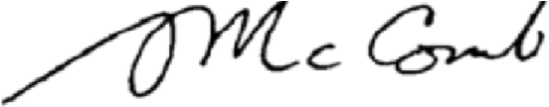
Scott McComb
Science Instructor, Science Olympiad coach

9229 East Marginal Way South Tukwila, WA 98108 206.631.7200 fax 206.631.7299 highline.schoolwires.net/raisbeckaviation

